PROJECT REPORT

**1.INTRODUCTION :-**

**A)OVERVIEW :-**

Thyroid neoplasms are classified as two molecular groups (BRAFV600E-like and RAS-like) or three groups (BRAFV600E-like, RAS-like, and non-BRAFV600E-/non-RAS-like) based on the mutational and gene expression profiles [7,8]. The BRAFV600E group is most commonly represented by papillary thyroid carcinoma (PTC).

These are papillary, follicular, medullary, and anaplastic. Papillary is the most common type. The four types differ in how aggressive they are. Thyroid cancer that is found at an early stage can often be treated successfully.

Thyroid classified in 4 stages and they are

Stage 1 thyroid cancer  
  
The tumor is 2 centimeters (cm) or smaller (less than an inch wide), and has not grown outside the thyroid.

Stage II:

This stage describes a larger, noninvasive tumor (T2) with no spread to lymph nodes (N0) and no metastasis (M0). Stage III: This stage describes a tumor larger than 4 cm but still contained in the thyroid (T3) with no spread to lymph nodes (N0) and no metastasis (M0).

Stage III:

This stage describes a tumor larger than 4 cm but still contained in the thyroid (T3) with no spread to lymph nodes (N0) and no metastasis (M0). Or, any localized tumor (T1, T2, or T3) with spread to the central compartment of lymph nodes (N1a) but no distant spread (M0).

Stage IV :

Thyroid cancer—also called metastatic disease is cancer that has spread beyond the thyroid to the soft tissues of the neck, lymph nodes in the neck, or distant locations in the body. The lungs and bone are the most frequent sites of distant spread

**B)PURPOSE :-**

To check for thyroid disease. To diagnose an underactive or overactive thyroid. To determine if an underlying disorder, such as Hashimoto's thyroiditis, Graves' disease, thyrotoxicosis, or thyroid inflammation, may be causing an underactive or overactive thyroid.

Thyroid tests check how well your thyroid is working. They are also used to diagnose and help find the cause of thyroid diseases such as hyperthyroidism and hypothyroidism. Thyroid tests include blood tests and imaging tests.Normal values are from 0.4 to 4.0 MI U/L for those with no symptoms of an under- or over-active thyroid. Some people with a TSH value over 2.0 MI U/L, who have no signs or symptoms suggestive of an under-active thyroid, may develop hypothyroidism sometime in the future.

**2.LITERATURE SURVEY :-**

**A)EXISTING PROBLEM :-**

The physical examination for a thyroid related problem starts with general examination. The weight and height are important markers, loss of weight recently may be due to thyrotoxicosis and gain of weight may be due to fluid retention of hypothyroidism.

Approach Considerations. The treatment goals for hypothyroidism are to reverse clinical progression and correct metabolic derangements, as evidenced by normal blood levels of thyroid-stimulating hormone (TSH) and free thyroxine (T4). Thyroid hormone is administered to supplement or replace endogenous production’

Initial screening for patients with suspected hypothyroidism is performed by measuring the TSH level. A positive thyroid peroxidase antibody assay confirms autoimmune thyroiditis as the cause. Thyroid ultrasonography is only indicated to evaluate suspicious structural thyroid abnormalities.

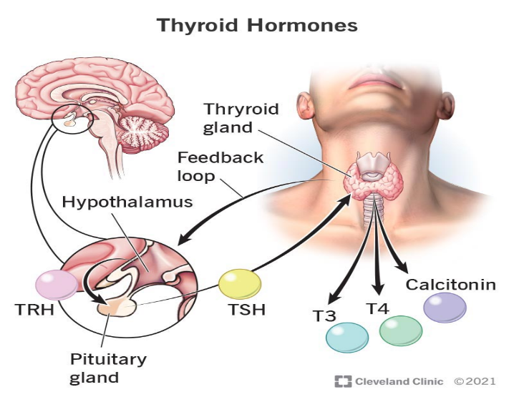

**B)PROPOSED SOLUTION :-**

Treatment for hypothyroidism usually includes taking the thyroid hormone medicine levothyroxine (Levo-T, Synthroid, others) every day. This medicine is taken by mouth. It returns hormone levels to a healthy range, eliminating symptoms of hypothyroidism.The main medications used for the treatment of an overactive thyroid are known as anti-thyroid drugs. These reduce the production of thyroid hormones. Thiamazole (also called methimazole) and carbimazole are the most commonly used anti-thyroid drugs. If these drugs aren't tolerated, propylthiouracil is sometimes used.

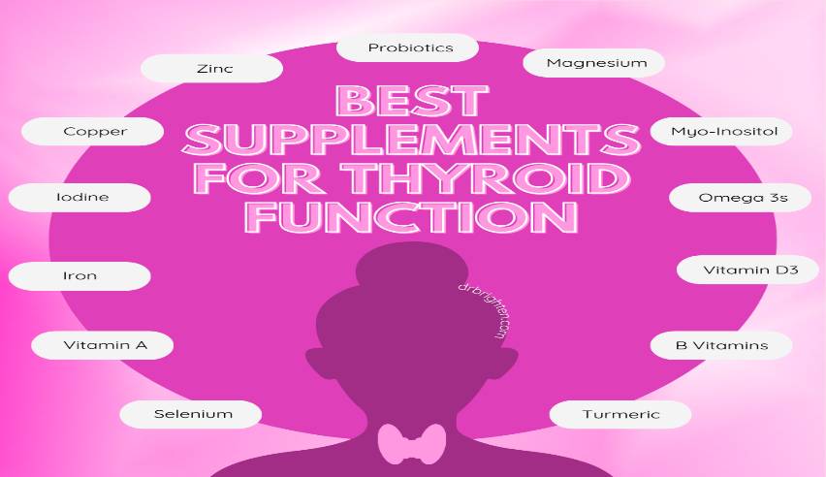

**3.THEORITICAL ANALYSIS :-**

**A)BLOCK DIAGRAM :-**

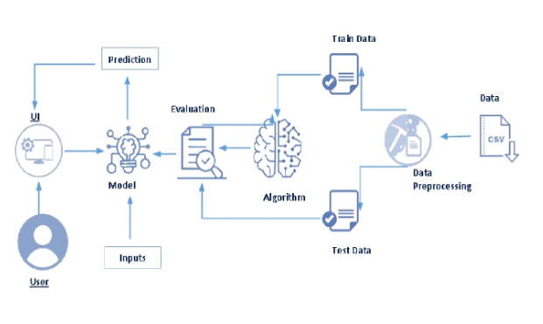

**B)HARDWARE/SOFTWARE DESIGNING :-**

**The hardware required for the project is either system or laptop to complete the project. Software requirement is anaconda and Py-charm to run the code in system. System support minimum** windows(6,7,8,9,10), 4GB RAM , 256 hard disk

**Hardware Required:**

system or laptop

**Software Required:**

Anaconda navigator , python , Spyder

**System Required:**

windows(6,7,8,9,10), 4GB RAM , 256 hard disk

**4.EXPERIMENTAL INVESTIGATIONS** :-

The first blood test typically done to diagnose hypothyroidism measures the level of thyroid-stimulating hormone (TSH) in the blood. If it's high, the test is done again, along with a blood test for the thyroid hormone T-4 . If the results show that TSH is high and T-4 is low, then the diagnosis is hypothyroidism.

* T4 test: This is done to measure the blood level of the hormone T4 (thyroxine). ...
* TSH test: A thyroid stimulating hormone (TSH) test can help tell how well the thyroid is working. ...
* T3 total test: The T3 total test measures the other major thyroid hormone in the blood.

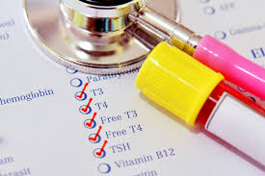

**5.FLOWCHART :-**

|  |
| --- |
| **DATA COLLECTION** |

|  |
| --- |
| **VISUALIZING AND ANALYZING THE DATA** |

|  |
| --- |
| **DATA PREPROCESSING** |

|  |
| --- |
| **SPLIT DATA** |

|  |  |
| --- | --- |
| **TEST DATA** | **TRAIN DATA** |

|  |
| --- |
| **FEATURE SELECTION** |

|  |
| --- |
| **MODEL SELECTION** |

|  |
| --- |
| **MODEL EVALUATION** |

|  |
| --- |
| **RESULT PREDICTION** |

**6.RESULT :-**

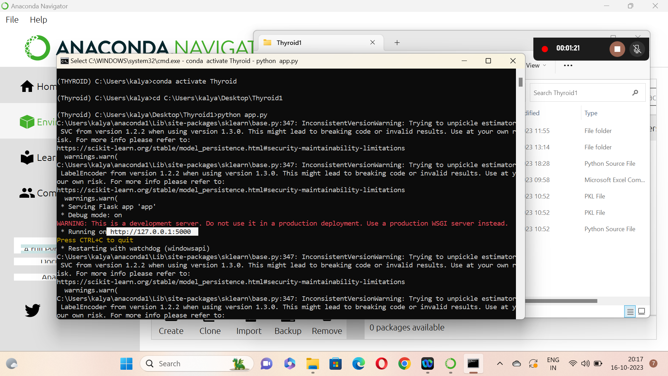

After completing the model building know we have to run app.py in anaconda navigator , after that we will get a URL copy and paste that URL in web browser we get the out put.

Now we get the home page and click on predict to enter the details. Now enter the required values in respective slots. And click on submit to get the final out put.

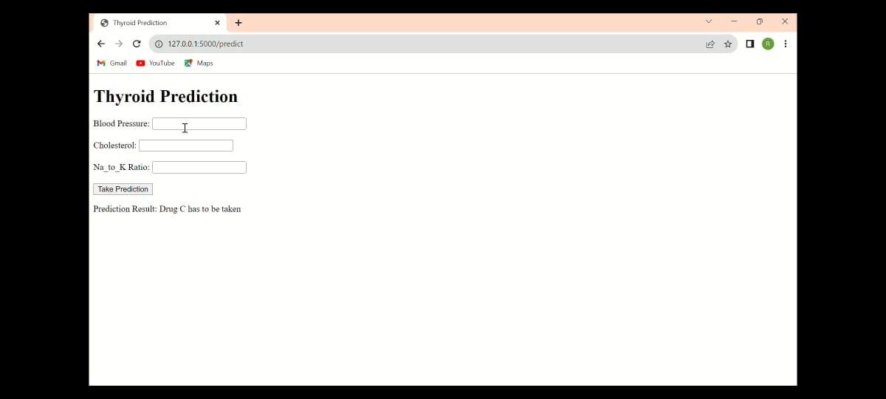

**7.ADVANTAGES AND DIS-ADVANTAGES :-**

**a)ADVANTAGES :-**

* Thyroid's main job is tocontrol the speed of your metabolism (metabolic rate).
* It helps to regulate many body functions by constantly releasing a steady amount of thyroid hormones into the bloodstream.
* For instance, if it is growing or cold, or during pregnancy – the thyroid gland produces more hormones.
* The major thyroid hormone secreted by the thyroid gland is thyroxine, also called T4.
* This occurs mainly in the liver and in certain tissues where T3 acts, such as in the brain.

**b)DIS-ADVANTAGES :-**

* An enlarged thyroid, or goitre, may cause problems with swallowing and breathing. Graves' disease can cause eye and skin problems.
* Hyperthyroidism. Hyperthyroidism can lead to Graves' disease, which has many symptoms, including sweating, arrhythmia (irregular heartbeat), weight loss, protruding eyes and nervousness.
* The most common thyroid problems involve abnormal production of thyroid hormones. Too much thyroid hormone results in a condition known as hyperthyroidism, while inadequate hormone production leads to hypothyroidism.
* Problems with the thyroid include a variety of disorders that can result in the gland producing too little thyroid hormone (hypothyroidism) or too much (hyperthyroidism).
* If your TSH level is higher than 5.0 I U /mL, then the lab will flag you as “high,” and you may experience the symptoms listed above 5.0 UI U / m L. Values of a TSH level of more than 10.0 UI U /mL need long-term thyroid supplements.

**8)APPLICATIONS :-**

* Thyroid disease is the general concept for a medical problem that prevents one’s thyroid from producing enough hormones.
* Thyroid disease can affect everyone—men, women, children, adolescents, and the elderly.
* Thyroid disorders are detected by blood tests, which are notoriously difficult to interpret due to the enormous amount of data necessary to forecast results.
* For this reason, this study compares eleven machine learning algorithms to determine which one produces the best accuracy for predicting thyroid risk accurately.
* The experiment shows that the ANN Classifier with an F1-score of 0.957 outperforms the other nine algorithms in terms of accuracy.

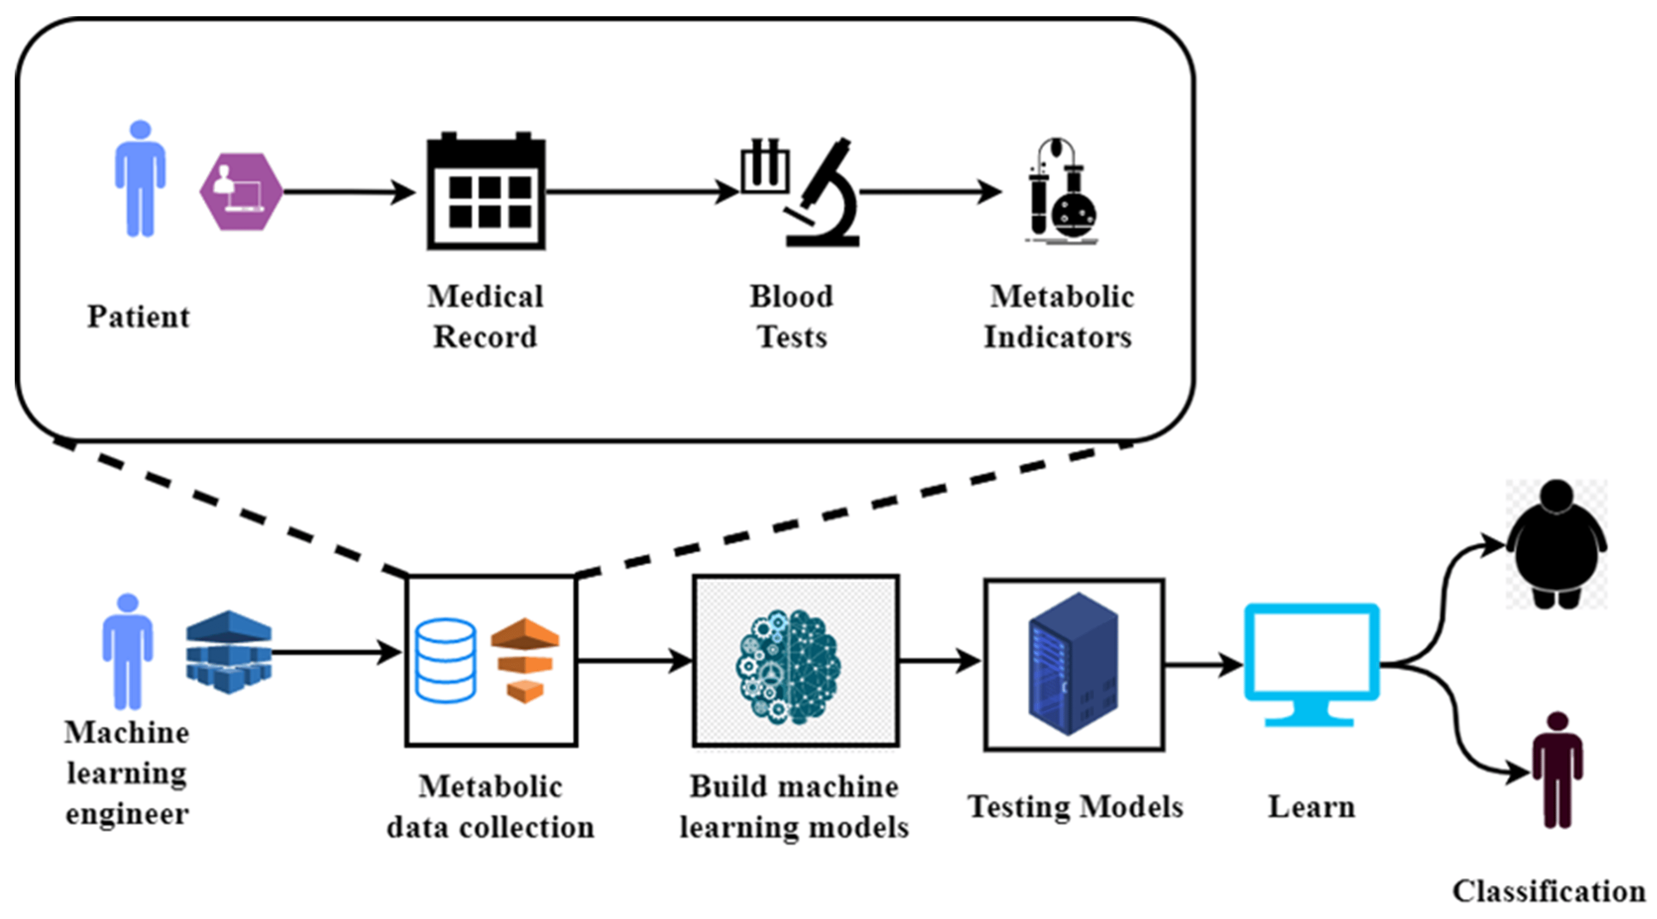

**9)CONCLUSION :-**

* Untreated hypothyroidism increases morbidity and mortality.
* The conclusions are valid with any physiological model in which increasing TSH levels progressively stimulate FT4 levels, increasing FT4 levels progressively inhibit TSH levels, and increasing TSH levels themselves progressively inhibit TSH levels.
* In children, failure to treat hypothyroidism can result in severe mental retardation.
* The thyroid gland produces hormones that regulate the body's metabolic rate, growth and development.
* Thyroid-ologists are endocrinologists who specifically study, diagnose, manage and treat the thyroid gland.

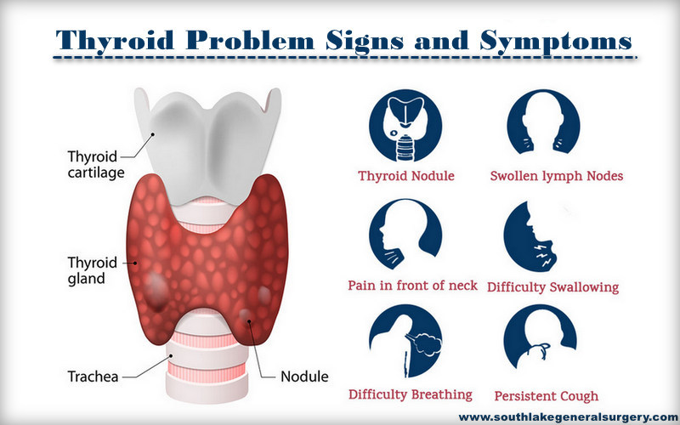

**10)FUTURE SCOPE :-**

* The two main types of thyroid disease are hypothyroidism and hyperthyroidism. Both conditions can be caused by other diseases that impact the way the thyroid gland works. Conditions that can cause hypothyroidism include: Thyroiditis: This condition is an inflammation (swelling) of the thyroid gland.
* The thyroid gland plays an important role in metabolism of human body. Abnormal growth of this gland is called Go-Iter. Iodine deficiency was thought to be the main cause of go-Iter.
* He goal of thyroid hormone treatment is to closely replicate normal thyroid functioning. Thyroid hormone is available as levothyroxine, which is biologically equivalent to your own thyroid hormone, thyroxine (T4). It is most commonly prescribed in tablet form but is now also available in gel capsule or liquid forms.
* Treatment for hypothyroidism usually includes taking the thyroid hormone medicine levothyroxine (Levo-T, Synthroid, others) every day. This medicine is taken by mouth. It returns hormone levels to a healthy range, eliminating symptoms of hypothyroidism.

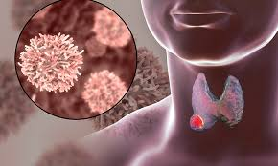

**11)BIBLIOGRAPHY :-**

**To complete this project we have referred to the recorded sessions mostly .**

**RECORDED LINK :-**

[**https://apschevip.teachable.com/purchase?product_id=5015540**](https://apschevip.teachable.com/purchase?product_id=5015540)

**For better understanding we have referred to a video on YouTube.**

**VIDEO LINK :-** [**https://youtu.be/S1kdYd4JGbg?si=dvHprwGdZgSVCfJG**](https://youtu.be/S1kdYd4JGbg?si=dvHprwGdZgSVCfJG)

**We have also referred to the GitHub repository of the mentors.**

**REPOSITORIES :-**

[**https://github.com/HariPrabu741/APSCHE-AI-ML**](https://github.com/HariPrabu741/APSCHE-AI-ML)

[**https://github.com/SaumyaMohandas/Apschesep_AIML**](https://github.com/SaumyaMohandas/Apschesep_AIML)

**APPENDIX –**

**This is the python source file**

from flask import Flask, render_template, request

import pickle

import numpy as np

import pickle

import pandas as pd

app = Flask(__name__)

# Load the pre-trained model from the pickle file

model=pickle.load(open(r"thyroid_1_model.pkl",'rb'))

le5=pickle.load(open(r"label_encoder.pkl",'rb'))

@app.route('/')

def home():

    return render_template('home.html')

@app.route('/predict', methods=['GET', 'POST'])

def predict():

    if request.method == 'POST':

        bp = float(request.form['bp'])

        cholesterol = float(request.form['cholesterol'])

        na_to_k = float(request.form['na_to_k'])

        # Prepare input data for prediction

        input_data = [[bp, cholesterol, na_to_k]]

        # Make a prediction using the loaded model

        prediction = model.predict(input_data)

        prediction=le5.inverse_transform(prediction)

        print(prediction)

        if (prediction==0):

            prediction = "Drug Y has to be taken"

        elif (prediction==1):

            prediction = "Drug A has to be taken"

        elif (prediction==2):

            prediction = "Drug B has to be taken"

        elif (prediction==3):

            prediction = "Drug C has to be taken"

        else:

            prediction = "Drug X has to be taken"

        return render_template('prediction.html', result=prediction)

    return render_template('prediction.html')

if __name__ == '__main__':

    app.run(debug=True)